hash table with linear probing:

1. Showing display and insertion:

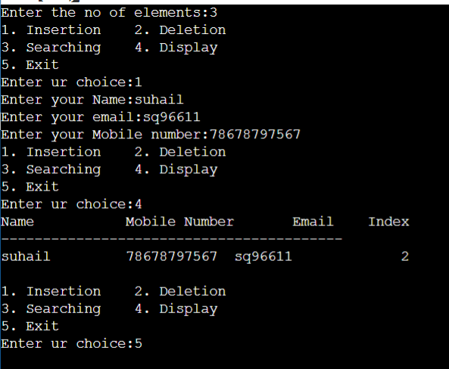

2)deleting and searching :

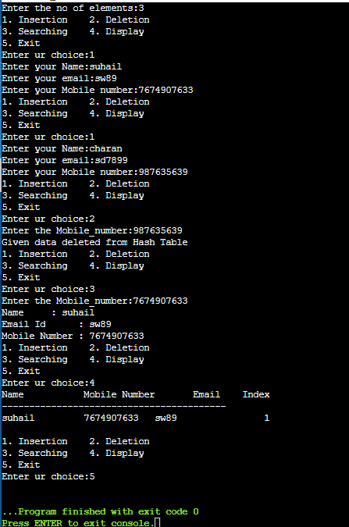

The above is executed successfully without any errors.